## PDF Sweep Version 2010 Proposal

There has been a lot of talk lately about grouping PDFs into certain buckets. There is a lot of logic around which letters to pull and by which client and what output to create (Excel manifests, text manifests, differently named PDFs).

There had initially been discussion about trying to group PDFs based on the client_defined_field we have added to the PDF name. Looping this way is a lit bit of madness so I am placing that in the furnace.

Here is what I have created.

Server:

* SQLETL

Database:

* Utilities

Table:

* PDFSweepGroupParameters

Columns:

* ID (pk)
* PMDClientID
* GroupType (a field/value pair)
* Value (a field/value pair)
* Active (true or false)
* InsertDate
* UpdateDate
* Rollup (true/false)
* GroupName – to be used in the document name in the event of a roll-up.

The “GroupTypes” are essentially anything that can be tied back to a patient or a communication. The currently configured values are:

* Contract
* DeliveryMethod
* Group
* GroupCode4
* Organization

The “Value” is the value to search for. So for a pair of “DeliveryMethod”->”Fax”, a PDF sweeping group would be created for that with the associated name and group as the output. The output would be the same as usual – a manifest and a set of pdfs.

You can make multiple “GroupType” to “Value” pairs and even inactivate ones at will.

Examples listed below:

**GroupType Value**

Contract H3957

DeliveryMethod Fax

DeliveryMethod Letter

Group 1

Group 2

GroupCode4 002076339

GroupCode4 00207633A

Organization 1

Organization 54

Organization 54002

NOTE: There is no way to group on ALL of a certain grouptype. You must identify the individual values (which you could, of course, fill in through some sort of other query).

A new feature is the “rollup”. This allows you to use multiples of a certain type. Like if you wanted both “Letter” and “Fax” DeliveryMethod documents in a single file – see below. The file would have “Methods of Delivery” in the name.

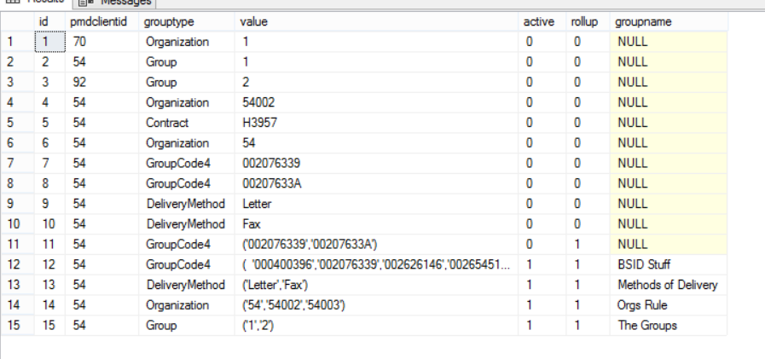

*Sample Table Values*

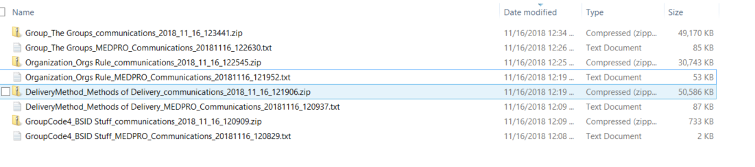

*Sample Export File Name Values*

Version History

|  |  |  |  |
| --- | --- | --- | --- |
| Version | Author | Date | Description |
| 1.0 | Brian Williams | 9/14/18 | Creation |
| 1.1 | Brian Williams | 11/16/18 | Updated with Rollup |
|  |  |  |  |
|  |  |  |  |